Report: Regional vs. National Housing Price Comparison
[Your Name]
Southern New Hampshire University

Introduction
Purpose: The purpose of this research is to determine whether the regional and national housing prices are significantly different. In this analysis, I will choose Mid Atlantic to be my region on focus. I will compare the population mean (national mean) with the sample mean (Mid Atlantic mean) by t- test. The null hypothesis for the test is that means are equal and the alternative hypothesis is that the means are not equal. A t-test will also be applied for square footage for homes mean test.

Sample:
State: this variable represents the states inside the county in the region where the data was collected.
County: It represents the counties inside the region where the data was collected.
Regions: it represents different geographical locations in the nation.
NB: the data must be collected within the same range of time. In my data analysis, I will use a sample of 100.

Questions and type of test:
We need some hypothetical questions which will guide us in our analysis:
- Is the sample mean significantly greater than the population mean?
In this case, our population parameter is the mean of the national housing prices, µ. It is calculated by adding all the national housing prices, then dividing by the total number of data. i.e.
$µ=\frac{\sum_{i=0}^{n}{X}}{N}$, Where X=national housing prices and N is the total number of data.
µ=294220
Here we are testing the hypothesis H₀:µ ≤ 294220 VS H_{a}: µ > 294220
- Is the sample mean in square footage equal to the population mean?
The null hypothesis for this is H₀; µ = 1954 VS H_{a}: µ ≠ 1954. We are required to perform a two tailed test.
- What is the probability that the population mean will fall between a set of variables for a certain proportional of times?
In the case of confidence interval, we will test the probability that the population mean lies between two values, say X₁ and X_{2.} I.e. P(X₁ ≤ µ ≤ X₂).

1-Tail Test
Hypothesis: [Define the population parameter. Write null and alternative hypotheses. Note: For means, define a hypothesis that is greater than the population parameter. Specify your significance level.]
Data analysis:
The population parameter is µ= 294220, and the hypothesis to be tested is H₀:µ ≤ 294220 VS H_{a}: µ > 294220 and with a significance level of 0.05, ie. α= 0.05. using a sample size of 100 in the Mid Atlantic region, we can summarize the descriptive statistics of the sample as follows:
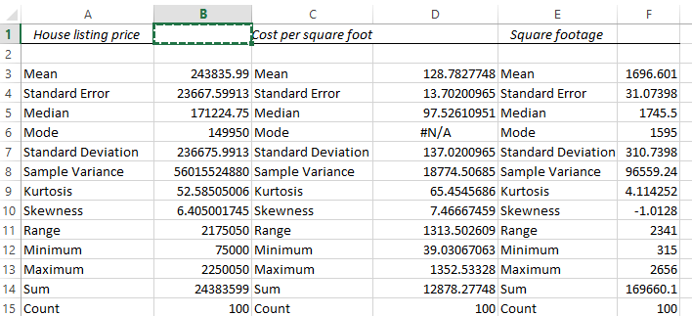
From the above descriptive, we notice that the mean is largest compared to mode and median. Therefore, we can conclude that the sample in the house listing variable has a weak positive skewness. Before be test the hypothesis, we should make sure that the following assumptions hold:
Assumptions of t- test
- Normality.
This assumption is that plotted results must form a bell shaped curve. This can be shown by plotting a histogram.
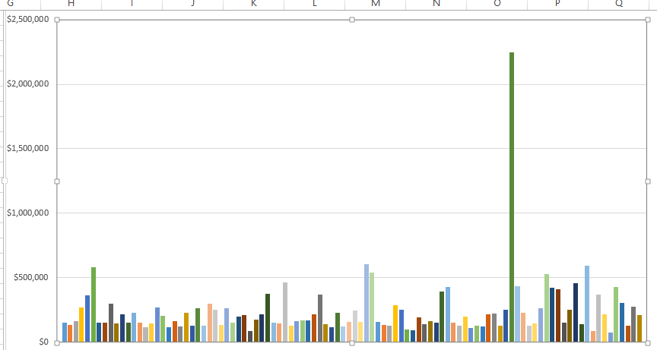
The histogram exhibits the normal distribution because it is bell shaped. Therefore we can conclude that the normality assumption is not violated. Moreover, since the sample size is large, from the central limit theorem and sampling methods, the sample means are approximately normally distributed.
- Large sample size is used
Statistically, a large sample size is a sample greater than 30. In this case, we have used a sample size of 100. Hence the assumption holds.
- Homoscedacity.
The next assumption is the assumption of homoscedacity. I will use the variance ratio to check for homogeneity of variance. If the ratio of the larger variance and the smallest variance is greater than 2, we assume homogeneity.

Hypothesis Test Calculations:
Under H₀, the test statistic is $t=\frac{mean-target}{standard error}$ =$\frac{243835.99-294220}{23667.59913}$ = -2.1288
Next we need to calculate the p- value using the degree of freedom and t statistic. To get the p- value we use: =T.DIST.RT([test statistic], [degree of freedom]). The degree of freedom is calculated by subtracting 1 from your sample size. T.DIST.RT(-2.1299,99)= 0.9821
Interpretation:
The p- value= 0.9821>>> α= 0.05.
Therefore, we fail to reject the null hypothesis
Decision: the sample mean is not greater than the population mean.

2-Tail Test
Hypotheses:
In this case, µ is the population parameter. For a 2- tailed test, we are testing that the sample mean is not equal to the population mean. We need to test the hypothesis H₀: µ = 1954 VS H_{a}: µ ≠ 1954.
The significance level is α= 0.05
Data Analysis:
The population parameter is µ= 1954, and the hypothesis to be tested is H₀:µ ≤ 1954 VS H_{a}: µ > 1954 and with a significance level of 0.05, ie. α= 0.05. using a sample size of 100 in the Mid Atlantic region, we can summarize the descriptive statistics of the sample as follows:
From the above descriptive, we notice that the mean is largest compared to mode and median. Therefore, we can conclude that the sample in the house listing variable has a weak positive skewness. Before be test the hypothesis, we should make sure that the following assumptions hold:
Assumptions of t- test
- Normality.
This assumption is that plotted results must form a bell shaped curve. This can be shown by plotting a histogram.
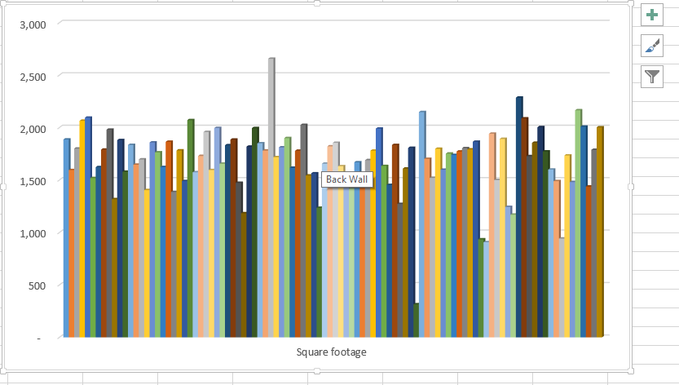
The histogram exhibits the normal distribution because it is bell shaped. Therefore we can conclude that the normality assumption is not violated. Moreover, since the sample size is large, from the central limit theorem and sampling methods, the sample means are approximately normally distributed.
- Large sample size is used
Statistically, a large sample size is a sample greater than 30. In this case, we have used a sample size of 100. Hence the assumption holds.
- Homoscedacity.
The next assumption is the assumption of homoscedacity. I will use the variance ratio to check for homogeneity of variance. If the ratio of the larger variance and the smallest variance is greater than 2, we assume homogeneity.

Hypothesis Test Calculations:
Under H_{0,} the test statistic is $t=\frac{mean-target}{standard error}$ =$\frac{1696.601-1954}{31.0798}$ = -8.5589
Next we need to calculate the p- value using the degree of freedom and t statistic. To get the p- value we use: =T.DIST.2T([test statistic], [degree of freedom]). The degree of freedom is calculated by subtracting 1 from your sample size. T.DIST.2T(-8.5589, 99)= 0.03582

Interpretation:
The p- value =0.03582< α= 0.05
Decision rule: We reject the null hypothesis.
Decision: the sample means are not equal to the population means. The average regional square footage are not equal average national square footage.

Comparison of the Test Results:
To calculate a 95 % confidence interval we use the command =CONFIDENCE.T(alpha, sd, n)
= CONFIDENCE.T(0.05, 23667.59913, 100)
= 46961.65141
Therefore confidence interval= mean +/- 46961.651
= 243835.99 +/- 46961.651
= (196874.339, 290797.641)
This means that there is a 95% probability that the housing prices range between 196874.339 and 290797.641
Final Conclusions
The regional and national housing prices are significantly different
I was surprised by the findings. This is because population mean, i.e. the average national housing price is not in the confidence interval.

